Bonjour Emeline!

Il est bon e’entendre en arrière. Charlotte Perriand est beau. Des guppys sont bons poissons. Mes parents sont copropriétaires de Synergy HomeCare. Ils prennent soin de grands-parents et personnes dans le besoin. Je conduis avec mon ami LeeAnn aller à l’ecole. Je suis sur le point d’obtenir mon permis de conduire. Je suis tout excité. Je vais conduire un camion. C’est grand et argenté. Es-tu va conduire? Je suis content que tu aimes Twenty One Pilots.

Here’s a late Merry Christmas and Happy New Year! What did you do to celebrate? On Christmas day I stayed at home with my family and opened presents, then went and saw the new star wars movie. On new year's eve I watched the countdown for the new year and drank apple cider when the ball dropped. As for the languages that I speak, I really only speak English and some French. I do know about 5 words in Korean because that is where my mom is from, I just never learned the language. It’s so cool you’re learning so many languages!

Now i’m gonna share a few pictures just so you can see what I look like, my favorite thing to do(band), my friends, and last but not least my dog!
This is our band at the end of our show. We made a star to complete the theme of our show “Proxima Centauri” which was based off of music called “The Planets”

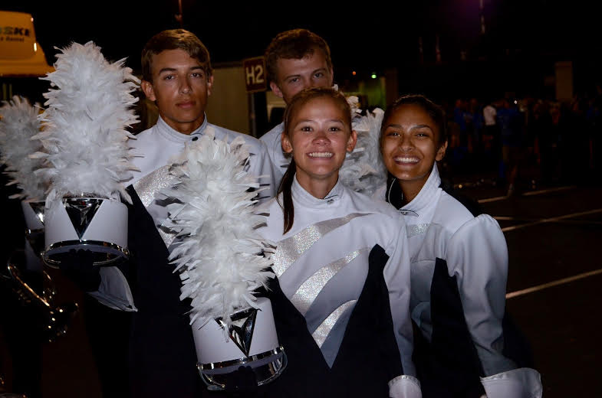
In this picture is me in the middle. The girl on my right is Ashima, one of my friends in my section. Behind me to the left is Nick, and behind me is Alex. They are also in my section (If I haven’t mentioned this I play the French Horn/ Mellophone when marching) (J’aime la fanfare)

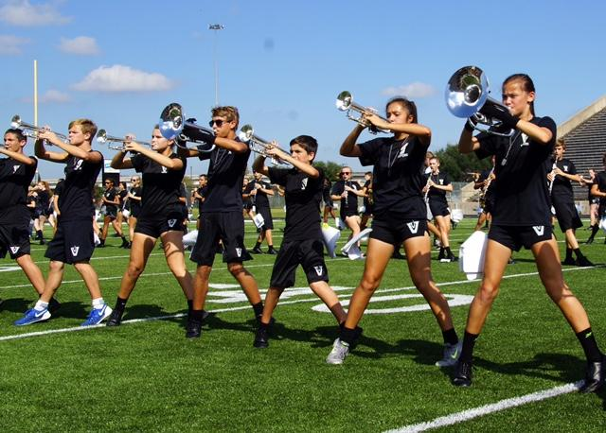
This picture is an example of our marching technique and what our rehearsals are like. Those are the clothes we wear underneath our uniform. I am on the far right, and to the left of me is a combination of trumpets and mellophones.

This is a picture of me and my friend LeeAnn (she is the person I carpool with). I just thought I should show you a picture of me outside of the band uniform :)

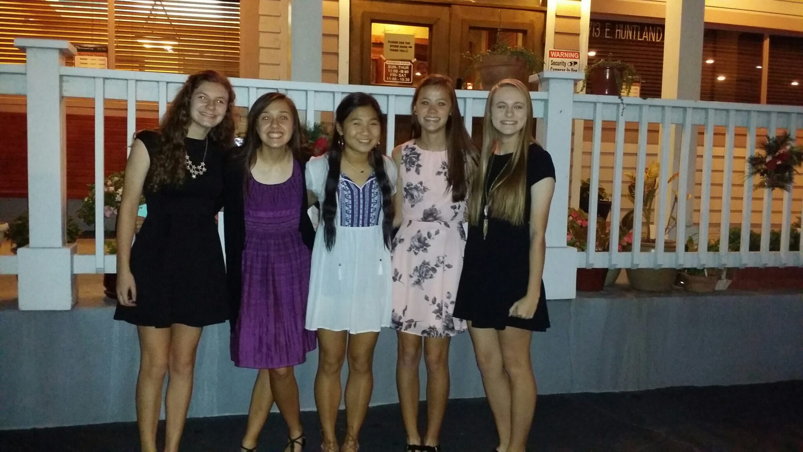

This is my main group of friends. In English, a slang word for a group of friends is to call them your “squad”. From left to right their names are Nicole, Avie, Cindy, and LeeAnn.

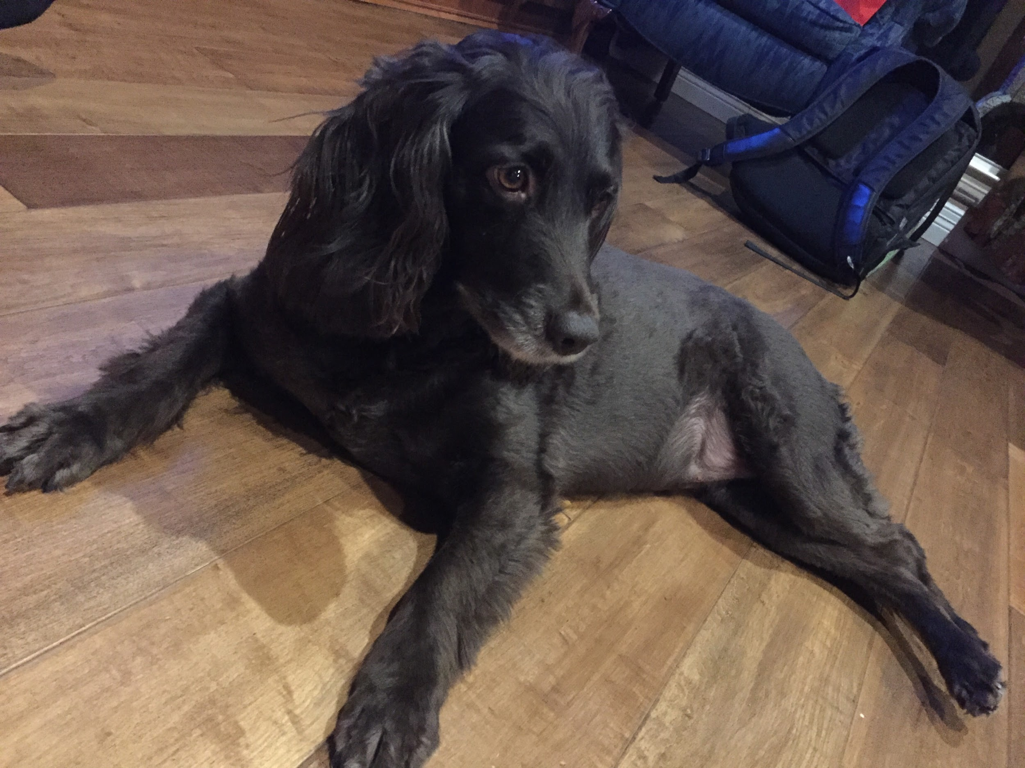
Une photo de mon chien, Coco! Elle est Boykin Spaniel.

À plus,
Cassie

